**Name: Riya Jacey Kurian**

**Roll No:29**

**Batch:RMCA(B)**

**Date:26/03/2021**

**NETWORKING & SYSTEM ADMINISTRATION LAB**

**Experiment No.: 1**

**Aim**

Familirization of Hardware Components.

**Procedure**

**COMPUTER HARWARE COMPONENTS**

Computer hardware refers to the physical components that make up a computer system There are many different kinds of hardware that can be installed inside, and connected to the outside, of a computer .

The term hardware distinguishes the tangible aspects of a computing device from software, which consists of written, machine-readable instructions or programs that tell physical components what to do and when to execute the instructions. Hardware and software are complementary.

Computer hardware can be categorized as being either internal or external components. Generally, internal hardware components are those necessary for the proper functioning of the computer, while external hardware components are attached to the computer to add or enhance functionality.

1. **Mother Board**

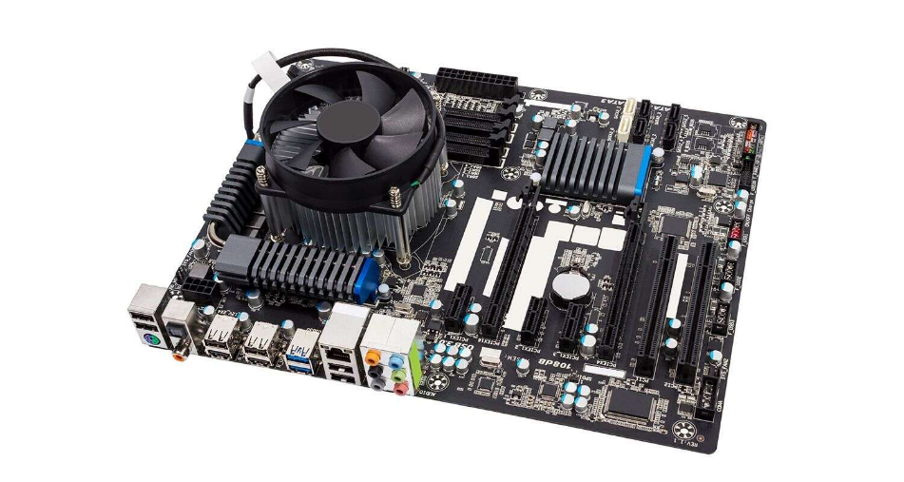

The motherboard is the piece of computer [hardware](https://www.lifewire.com/computer-hardware-2625895) that can be thought of as the "backbone" of the PC, or more appropriately as the "mother" that holds all the pieces together.

The IBM Personal Computer that was released in 1981, is considered to be the very first computer motherboard (it was called a "planar" at the time).Popular motherboard manufacturers include ASUS, AOpen, Intel, ABIT, MSI, Gigabyte, and Biostar.

In a desktop, the motherboard is mounted inside the case, opposite the most easily accessible side. It's securely attached via small screws through pre-drilled holes.

The front of the motherboard contains ports that all of the internal components connect to. A single socket/slot houses the CPU. Multiple slots allow for one or more memory modules to be attached. Other ports reside on the motherboard, and these allow the hard drive and optical drive (and floppy drive if present) to connect via data cables.

Small wires from the front of the computer case connect to the motherboard to allow the power, reset, and LED lights to function. Power from the power supply is delivered to the motherboard by use of a specially designed port.

Also on the front of the motherboard are a number of peripheral card slots. These slots are where most video cards, sound cards, and other expansion cards are connected to the motherboard.

On the left side of the motherboard (the side that faces the back end of the desktop case) are a number of ports. These ports allow most of the computer's external peripherals to connect such as the monitor, keyboard, mouse, speakers, network cable and more.

All modern motherboards also include USB ports, and increasingly other ports like HDMI and FireWire, that allow compatible devices to connect to your computer when you need them—devices like digital cameras, printers, etc.

The desktop motherboard and case are designed so that when peripheral cards are used, the sides of the cards fit just outside the back end, making their ports available for use.

1. **CPU (central processing unit)**

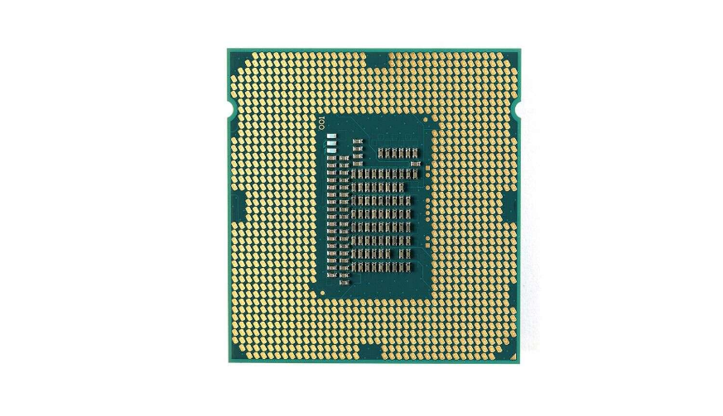

A modern CPU is usually small and square, with many short, rounded, metallic connectors on its underside. Some older CPUs have pins instead of metallic connectors.

The CPU attaches directly to a CPU "socket" (or sometimes a "slot") on the motherboard. The CPU is inserted into the socket pin-side-down, and a small lever helps to secure the processor.

After running even a short while, modern CPUs can get very hot. To help

dissipate this heat, it's almost always necessary to attach a heat sink and a

fan directly on top of the CPU. Typically, these come bundled with a CPU purchase.

The CPU (Central Processing Unit or processor) is responsible for processing all information from programs run by your computer.

The ‘clock speed’, or the speed at which the processor processes information, is measured in gigahertz (GHz). This means that a processor advertising a high GHz rating will likely perform faster than a similarly specified processor of the same brand and age.

1. **RAM(random access memory)**

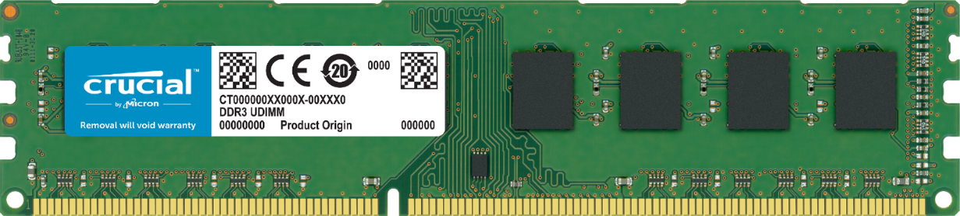

Random Access Memory, or RAM, is hardware found in the memory slots of the motherboard. The role of RAM is to temporarily store on-the-fly information created by programs and to do so in a way that makes this data immediately accessible. The tasks that require random memory could be; rendering images for graphic design, edited video or photographs, multi-tasking with multiple apps open (for example, running a game on one screen and chatting via Discord on the other).

Integrated RAM chips are available in two form:

**SRAM :**

The SRAM memories consist of circuits capable of retaining the stored information as long as the power is applied. That means this type of memory requires constant power. SRAM memories are used to build Cache Memory.

**DRAM :**

DRAM stores the binary information in the form of electric charges applied to capacitors. The stored information on the capacitors tends to lose over a period of time and thus the capacitors must be periodically recharged to retain their usage. The main memory is generally made up of DRAM chips.

1. **Hard drive**

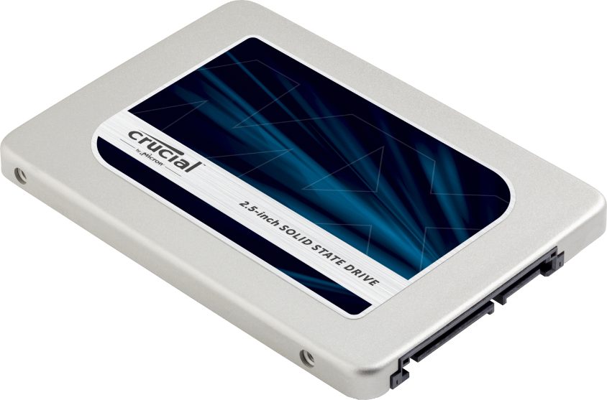

The hard drive is a storage device responsible for storing permanent and temporary data. This data comes in many different forms, but is essentially anything saved or installed to a computer: for example, computer programs, family photos, operating system, word-processing documents, and so on.

There are two different types of storage devices: the traditional hard disk drive (HDD) and the newer solid state drives (SSD). Hard disk drives work by writing binary data onto spinning magnetic disks called platters that rotate at high speeds, while a solid-state drive stores data by using static flash memory chips.

The sides of the hard drive have pre-drilled, threaded holes for easy mounting in the 3.5-inch drive bay in the computer case. Mounting is also possible in a smaller 2.5-inch drive and larger 5.25-inch drive bay with an adapter. The hard drive is mounted, so the end with the connections faces inside the computer. Laptops often use a 2.5-inch hard drive or SSD.

1. **GPU(graphics processing unit)**

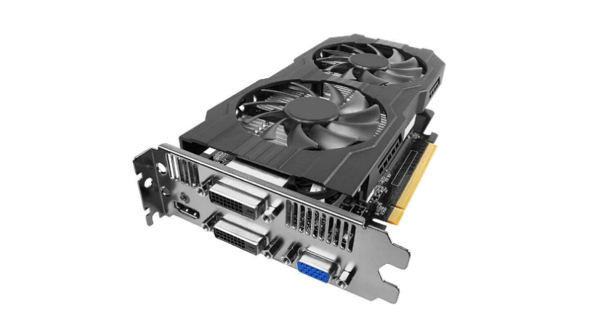

Graphics Processing Unit (GPU) is a chip or electronic circuit capable of rendering graphics for display on an electronic device. The GPU was introduced to the wider market in 1999 and is best known for its use in providing the smooth graphics that consumers expect in modern videos and games.

A graphics processing unit (GPU) is a specialized electronic circuit designed to rapidly manipulate and alter memory to accelerate the creation of images in a frame buffer intended for output to a display device. GPUs are used in embedded systems, mobile phones, personal computers, workstations, and game consoles.

Modern GPUs are very efficient at manipulating computer graphics and image processing. Their highly parallel structure makes them more efficient than general-purpose central processing units (CPUs) for algorithms that process large blocks of data in parallel. In a personal computer, a GPU can be present on a video card or embedded on the motherboard. In certain CPUs, they are embedded on the CPU die.

1. **PSU (power supply unit)**

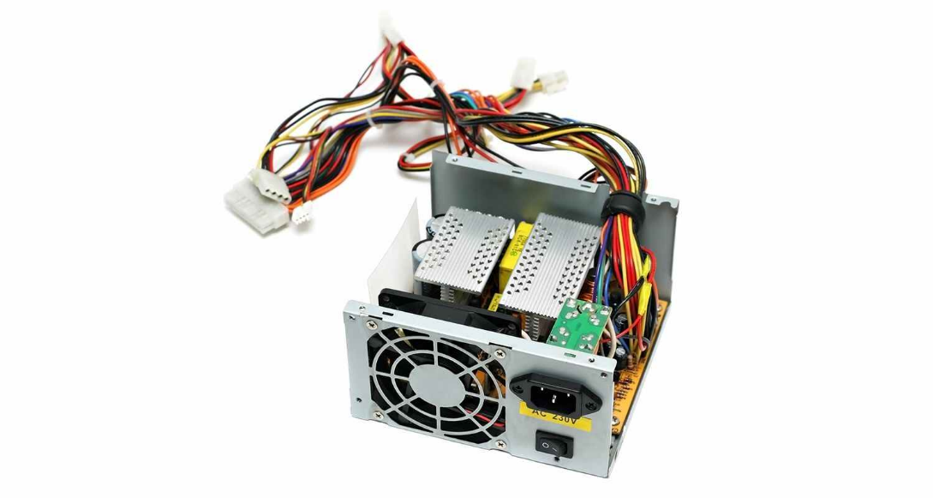

A power supply unit, commonly abbreviated as PSU, does more than just supply your computer with power. It is the point where power enters your system from an external power source and is then allocated by the motherboard to individual component hardware. Not all power supplies are made equally however, and without the right wattage PSU your system will fail to work.

A modern computer will generally need a PSU that’s rated between 500W – 850W to effectively power all hardware, although the size of the PSU will depend entirely on the power consumption of the system. Computers that are used for highly intensive tasks such as graphic design or gaming will require more powerful components and thus will need a bigger PSU to cater to this additional need.

Without the right amount of power, components won’t be able to run effectively and the computer might experience crashes or simply fail to boot at all. It’s recommended to have a power supply that more than covers your system usage. Not only do you guard yourself against system failure, you also future-proof yourself against needing a new PSU when you upgrade to more powerful PC components.

1. **Video Card**

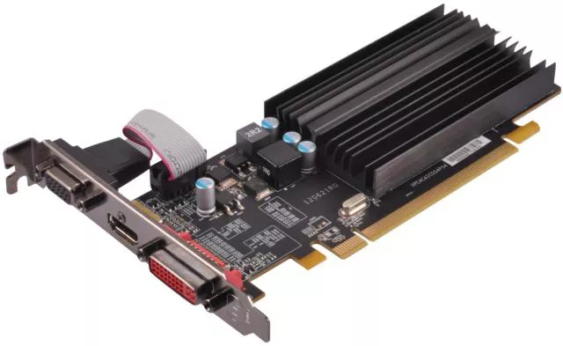

The video card is an expansion card that allows the computer to send graphical information to a video display device such as a monitor, TV, or projector.

Some other names for a video card include graphics card, graphics adapter, display adapter, video adapter, video controller, and add-in boards (AIBs).

A staggering number of companies manufacture video cards, but almost every one includes a graphics processing unit (GPU) from either NVIDIA Corporation or AMD.

Many modern computers don't have video expansion cards but instead, have onboard video GPUs integrated directly onto the motherboard. This allows for a less expensive computer but also for a less powerful graphics system. This option is wise for the average business and home user not interested in advanced graphics capabilities or the latest games.

1. **Optical Disc Drive**

An optical drive is a piece of computer hardware about the size of a thick softcover book. The front has a small Open/Close button that ejects and retracts the drive bay door. This is how media like CDs, DVDs, and BDs are inserted into and removed from the drive.

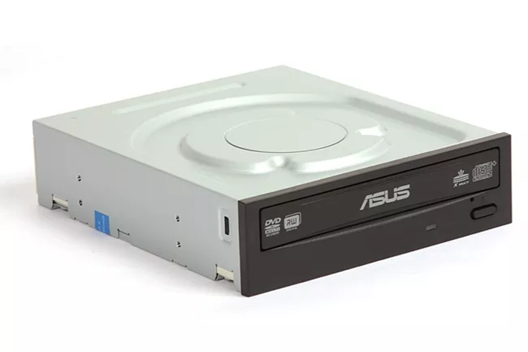

The sides have pre-drilled, threaded holes for easy mounting in the 5.25-inch drive bay in the computer case. The optical drive is mounted to the end with the connections facing inside the computer and the end with the drive bay facing outside.

The back end of the optical drive contains a port for a cable that connects to the motherboard. The type of cable used will depend on the type of drive, but is almost always included with an optical drive purchase. Also here is a connection for power from the power supply.

1. **System cooling Fan**

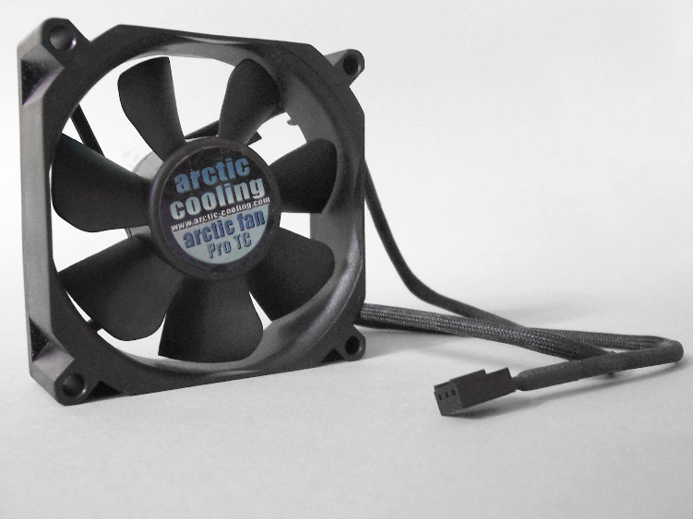

A computer fan is any fan inside, or attached to, a computer case used for active cooling. Fans are used to draw cooler air into the case from the outside, expel warm air from inside and move air across a heat sink to cool a particular component. Both axial and sometimes centrifugal (blower/squirrel-cage) fans are used in computers. Computer fans commonly come in standard sizes, such as 120 mm (most common), 140 mm, 240 mm, and even 360 mm. Computer fans are powered and controlled using 3-pin or 4-pin fan connectors.

Fans are used to move air through the computer case. The components inside the case cannot dissipate heat efficiently if the surrounding air is too hot. Case fans may be placed as intake fans, drawing cooler outside air in through the front or bottom of the chassis (where it may also be drawn over the internal hard drive racks), or exhaust fans, expelling warm air through the top or rear.

1. **SSD**

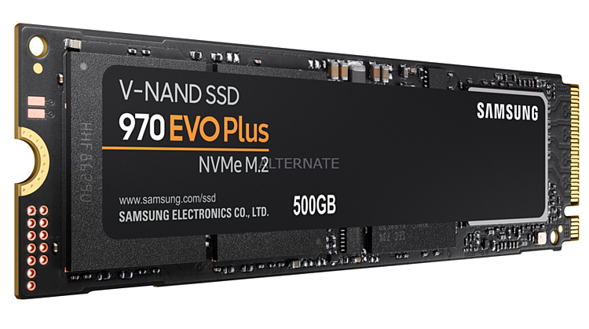

A solid-state drive (SSD) is a solid-state storage device that uses integrated circuit assemblies to store data persistently, typically using flash memory, and functioning as secondary storage in the hierarchy of computer storage. It is also sometimes called a semiconductor storage device, a solid-state device or a solid-state disk.

SSDs use flash-based memory, which is much faster than a traditional mechanical hard disk. Upgrading to an SSD is one of the best ways to speed up your computer.

There are two common types of SSDs. The oldest form of SSD uses the now aging SATA III interface. It has the advantage of nearly universal compatibility, but is relatively slow. Some newer PCs don't have a SATA connector at all; this interface is being phased out.Newer SSDs use the Nonvolatile Memory Express (NVMe) standard. This is a faster design with lower latency, and connects to computers via the PCIe interface rather than SATA. PCIe is the same interface that connects high-speed components like graphics cards and sound cards.

************************************************************